
系統資料流說明書
system DataFlow Diagram
R1-SSA-PLN-001 Security Planning
2025年4月1日
ICP Taiwan
Copyright © 2025 ICP Corp. All Rights Reserved.
Content
1. Introduction 4
1.1. Purpose and Objectives 4
1.2. Scope of application 4
1.3. Glossary of Term and Definitions 5
1.4. Abbreviations 6
1.5. Applicable Documents 8
1.5.1. Related Documents 8
2. Project Asset and SuC Description 8
2.1. System Under Consideration 8
2.2. The Assets of SuC 11
2.2.1. SCADA System 11
2.2.2. Safety Control System 11
2.2.3. Configuration & Auxiliary Management System 12
2.3. HLRA updated Network Diagram 12
2.4. SuC dataflow diagram 13
3. Defense-in-Depth Architecture of the SuC 20
3.1. From Outside Zone to Purdue Level 3 20
3.2. From Purdue Level 3 to Purdue Level 2 21
3.3. From Purdue Level 2 to Purdue Level 1 21

Release and Revision History
Version | Release Date | Effective Date | Description
1.0 | April 1, 2025 |  | Initial release of the document.

Introduction

Purpose and Objectives
The purpose of this document is to provide a detailed description of the System Data Flow Diagram for the ICP 2L Laboratory project. It outlines the structure and flow of data within the system, offering a clear understanding of the project's data handling processes. Additionally, this document includes an updated network diagram, reflecting the results of the initial level risk assessment (ILRA), also known as the Threat and Preliminary Risk Assessment, conducted for the ICP 2L Laboratory project.

Scope of application
The System under Consideration (SuC) encompasses the power switch control system and the associated networks of the substation. The scope of systems covered by this management plan includes the following:
- Power SCADA system
- Safety Control system
- Configuration & Auxiliary Management system

Glossary of Term and Definitions
Term | Description
Asset Owner | An individual or organization responsible for managing one or more Industrial Automation and Control Systems (IACS).
Automation Solution | A control system along with any complementary hardware and software components, all installed and configured to operate within an IACS.
Component | A part or element that contributes to the overall structure of a product or system.
Dependent Component | An external component that a product or system relies on for its operation.
Integration Service Provider | A service provider responsible for integration activities related to an Automation Solution, including design, installation, configuration, testing, commissioning, and handover.
Maintenance Service Provider | A service provider that offers ongoing support and maintenance for an Automation Solution following handover.
Product Supplier | A manufacturer of hardware and/or software products.
Recovery Point Objective (RPO) | The maximum allowable period of data loss in the event of a disaster (e.g., data corruption).
Recovery Time Objective (RTO) | The maximum length of time that system components or operational functions can be in a recovery phase without adversely affecting the organization’s mission or business operations.
Service Provider | An individual or organization (either internal or external, including manufacturers) that offers specific support services and associated supplies under an agreement with the asset owner.

Abbreviations
Abbreviation | Clarification
SCADA | Supervisory Control and Data Acquisition
HMI | Human Machine Interface
IED | Intelligent Electronic Device
RTU | Remote Terminal Unit
PLC | Programmable Logic Controller
RPO | Recovery Point Objective
RTO | Recovery Time Objective
ILRA | Initial Level Risk Assessment
HLRA | High Level Risk Assessment
SuC | System under Consideration
SNMP | Simple Network Management Protocol
UDP | User Datagram Protocol
TCP | Transmission Control Protocol
Syslog | System Logging Protocol
RADIUS | Remote Authentication Dial-In User Service
DNP3 | Distributed Network Protocol version 3
LDAP | Lightweight Directory Access Protocol
MMS | Manufacturing Message Specification
PTPv2 | Precision Time Protocol Version 2
GOOSE | Generic Object Oriented Substation Event
MFA | Multi-Factor Authentication

Applicable Documents

Related Documents
No | Doc Code | Employer Doc Code | Doc Title | Ver
1 |  |  | Simple Network Diagram | 1
2 |  |  | Dataflow Diagram | 1

Project Asset and SuC Description

System Under Consideration
A substation is a complex system consisting of various components such as transformers, capacitors, voltage regulators, and circuit breakers. In smart grid systems, automated substation control will be widely implemented to enable real-time monitoring and control via local area networks. Figure 1 illustrates the system architecture of a substation.
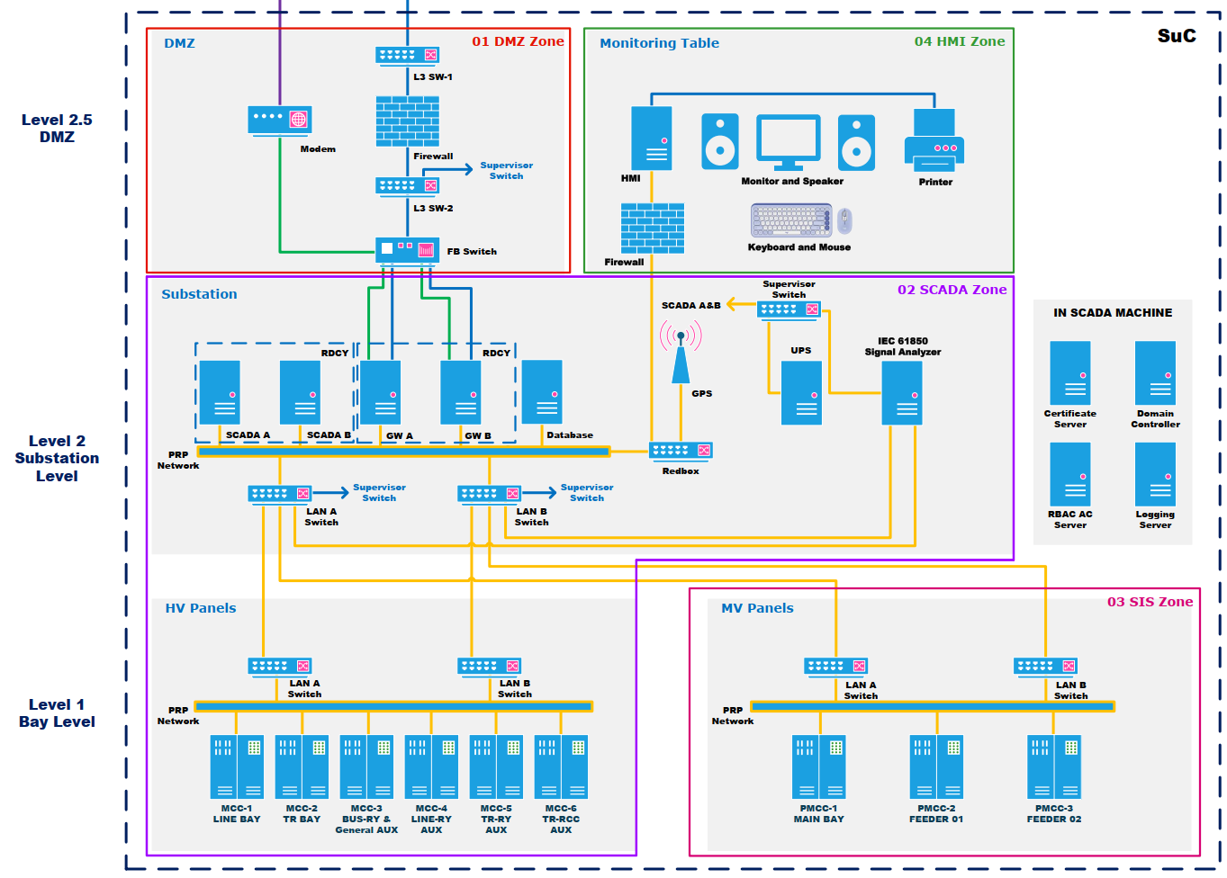
Figure 1 The system architecture diagram of the substation
Substations are crucial for ensuring the stability of electrical supply and load management across low, medium, and high voltage distribution networks. To maintain the efficient operation of substations and associated equipment, such as line-mounted switches and capacitors, utilities typically rely on SCADA (Supervisory Control and Data Acquisition) systems for automated monitoring and control.
New installations generally incorporate SCADA systems to oversee and manage substations and their components. However, older facilities can also benefit from adopting or upgrading SCADA systems to leverage the latest technologies. A new or upgraded SCADA system not only enhances monitoring and control capabilities but also extends the lifespan of substations and related equipment by providing real-time data for identifying and addressing minor issues before they escalate. Additionally, the wealth of historical data generated by SCADA systems aids in optimizing preventive maintenance schedules, reducing related costs.
Electrical distribution systems often consist of numerous remote locations, and managing these sites has traditionally been challenging. To address this, utilities began deploying remote terminal units (RTUs) at substations. Initially custom-built, RTUs evolved to incorporate standard hardware such as programmable logic controllers (PLCs) or industrial PCs. More recently, intelligent electronic devices (IEDs) have become prevalent in substations, typically communicating with the RTU to enhance data collection and control functions.
Switchgear feeders control power distribution to various electrical loads at substations, and sensors on the switchgear capture critical data such as current, voltage, power, and operational status. This data is transmitted to the RTU and subsequently polled by the SCADA system.
A SCADA system typically consists of a master control station with one or more PC-based human-machine interfaces (HMIs). In larger substations, additional secondary control stations with HMIs may be present, along with local HMIs for on-site operators. These operators use the HMIs to monitor and manage substation operations and related equipment. Modern SCADA systems are highly efficient at processing vast amounts of data necessary for tracking the operational status of power lines, cables, and equipment, ensuring optimal performance and reliability.

The Assets of SuC
The initial assets of the system under consideration (SuC) for this project include the following:

SCADA System
- SCADA Server
- Gateway
- HMI
- IED (Bay Control Unit)
- Ethernet Switch

Safety Control System
- IED (Protection Relay)
- Ethernet Switch

Configuration & Auxiliary Management System
Wireless Access Point (capable of connecting to a laptop)

HLRA updated Network Diagram
Figure 2, titled "Simple Network Diagram of the SuC," presents the revised network architecture following the HLRA (High Level Risk Assessment). This diagram incorporates the segmentation of zones and conduits as identified through the analysis. Additionally, it outlines the preliminary set of required security countermeasure equipment. For comprehensive details, please refer to the document "ICP 2L Lab – Simple Network Diagram.pdf".
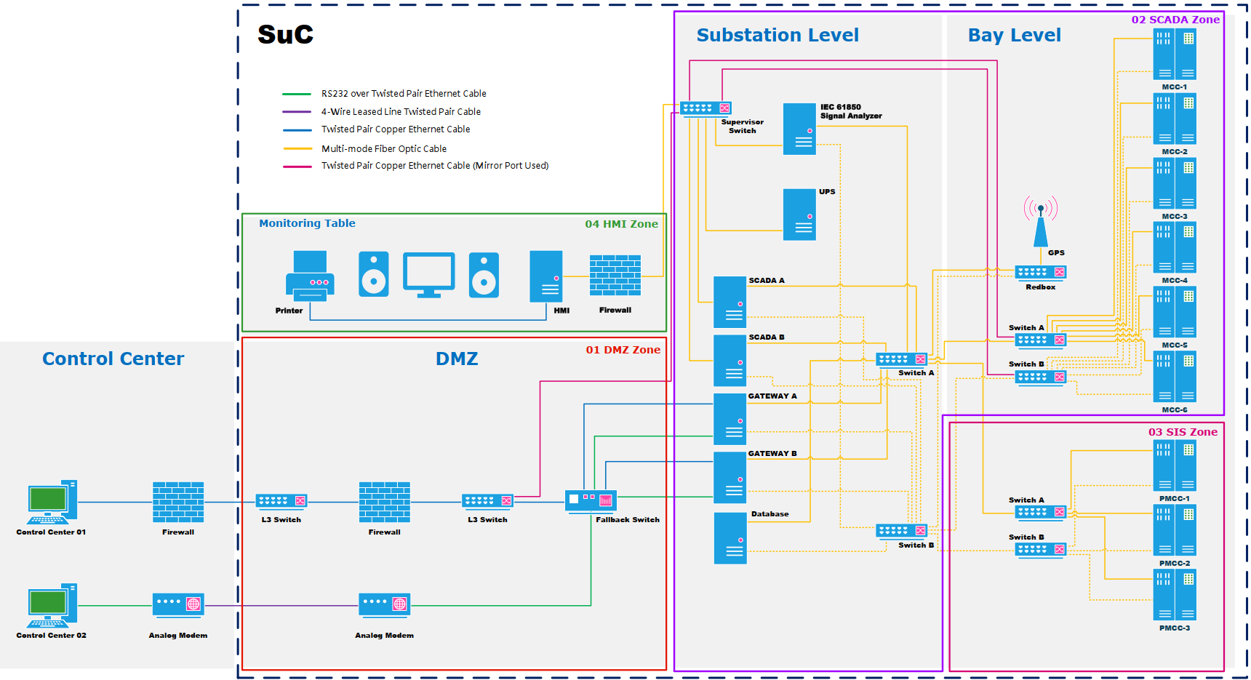
Figure 2 The system architecture diagram of the substation

SuC dataflow diagram
The data flow diagram of the SuC is illustrated in Figure 3 – Data Flow Diagram of the SuC. Following the ILRA analysis and the segmentation of zones and conduits, the diagram also preliminarily indicates the required security countermeasure equipment.
For further details, please refer to ICP 2L Lab Dataflow Diagram.pdf.
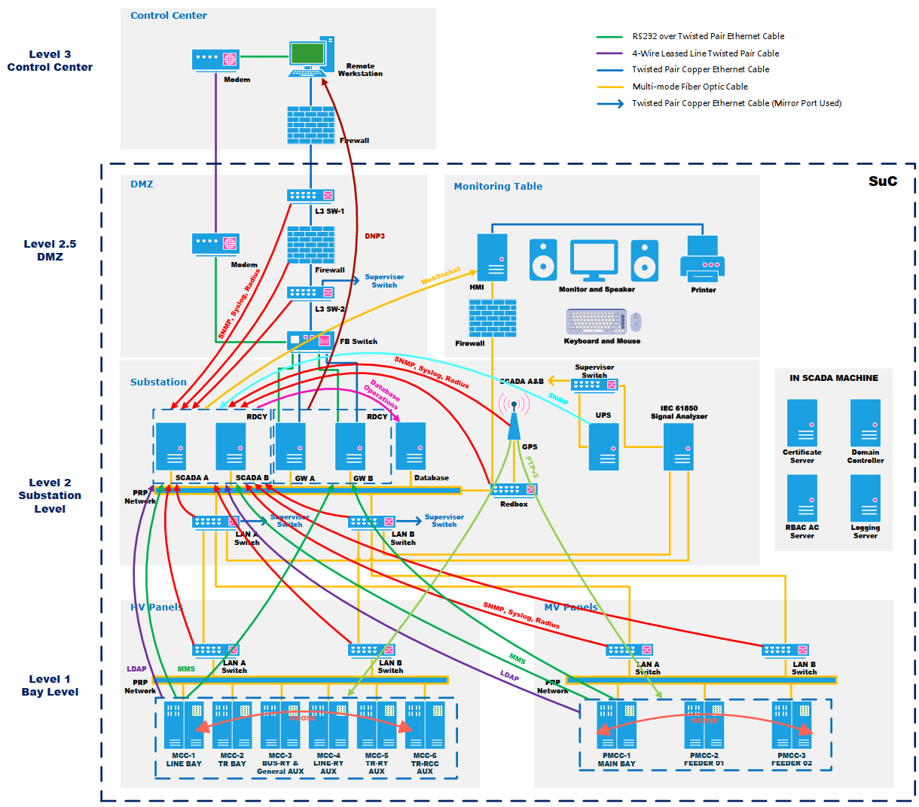
Figure 3 The Dataflow diagram of the substation

No | Description | From | To | Protocol | Type | Port
1 | Receive monitoring status from network devices. | HW-01-001  HW-01-002  HW-01-003  HW-02-007  HW-02-008  HW-02-009  HW-02-010 | HW-02-001  HW-02-002 | SNMP | UDP | 162
2 | Receive logs from network devices. | HW-01-001  HW-01-002  HW-01-003  HW-02-007  HW-02-008  HW-02-009  HW-02-010 | HW-02-001  HW-02-002 | Syslog | UDP | 514
3 | Used for authentication and authorization logging. | HW-01-001  HW-01-002  HW-01-003  HW-02-007  HW-02-008  HW-02-009  HW-02-010 | HW-02-001  HW-02-002 | RADIUS | UDP | 1812, 1813
4 | Provide monitoring for the Taipower Dispatch Center. | HW-02-003  HW-02-004 | TPC ADCC | DNP3 | TCP | 20000
5 | Provide display and data to the HMI. | HW-02-001  HW-02-002 | HW-04-002 | WebSocket | TCP | 33333
6 | SCADA performs operations on the database. | HW-02-001  HW-02-002 | HW-02-006 | MySQL | TCP | 3306`
7 | Provide UPS transmission status and alarms. | HW-02-011 | HW-02-001  HW-02-002 | SNMP | UDP | 162
8 | Provide authentication and authorization for IED devices. | HW-02-015  HW-02-016  HW-02-017  HW-02-018  HW-02-019  HW-02-020  HW-03-003  HW-03-004  HW-03-005 | HW-02-001  HW-02-002 | LDAP | TCP | 389
9 | IEDs send signals back to the system via IEC 61850 Protocol. | HW-02-015  HW-02-016  HW-02-017  HW-02-018  HW-02-019  HW-02-020  HW-03-003  HW-03-004  HW-03-005 | HW-02-001  HW-02-002  HW-02-003  HW-02-004 | MMS | TCP | 102
10 | Provide time synchronization for IED devices. | HW-02-010 | HW-02-015  HW-02-016  HW-02-017  HW-02-018  HW-02-019  HW-02-020  HW-03-003  HW-03-004  HW-03-005 | PTPv2 | Broadcast | N/A
11 | Implement protection coordination between IED devices. | HW-02-015  HW-02-016  HW-02-017  HW-02-018  HW-02-019  HW-02-020  HW-03-003  HW-03-004  HW-03-005 | HW-02-015  HW-02-016  HW-02-017  HW-02-018  HW-02-019  HW-02-020  HW-03-003  HW-03-004  HW-03-005 | GOOSE | Multicast | N/A

Defense-in-Depth Architecture of the SuC
The defense-in-depth architecture of the SuC is designed based on layered security principles and follows the Purdue Enterprise Reference Architecture. The implementation includes the following key security controls:

From Outside Zone to Purdue Level 3
- Deploy a firewall to restrict permitted asset and service connections from the Substation Zone to the Supervisory and Service Zones.
- Enforce multi-factor authentication (MFA) for any connection initiated from the Substation Zone.
- Ensure encryption is applied to all connections originating from the Substation Zone.
- Deploy a firewall to restrict permitted asset and service connections from the Working Zone to the Supervisory Zone.
- Apply secure access controls for web-based services accessed from the Working Zone to the Supervisory Zone.
- Encrypt all connections originating from the Working Zone.

From Purdue Level 3 to Purdue Level 2
Deploy a managed switch with an enforced asset whitelist to restrict asset and service connections from the Service Zone to the Supervisory, Safety, and Control Zones.

From Purdue Level 2 to Purdue Level 1
- Deploy a router with firewall functionality and asset whitelisting to restrict connections from the Service Zone and Supervisory Zone to the Safety and Control Zones.
- Configure firewall rules on the router to strictly limit permitted asset and service connections from the Supervisory Zone to the Safety Zone.

